**Reduction Of Storage Space In CCTV And IP Cameras using Internet Of Things**

M.Saravanan, Ra.Sharath, J.Surya

Department of Computer Science and Engineering

Panimalar Engineering College

Chennai

Abstract Smart camera has been used for surveillance system for many places. Internet of things is the communication of anything with any other thing, the communication mainly transferring of useable data, for example a sensor in a room to monitor and control the temperature. This paper aims to describe a security alarm system using Internet of things which helps to monitor and get alarms when motion is detected and sends photos and videos to a cloud server. The photos and videos are sent directly to a cloud server, when the cloud is not available then the data is stored locally on the Raspberry Pi and sent when the connection resumes. Therefore, advantages like these make this application ideal for monitoring homes in absence. The purpose of the project is to make a system, which would detect and take snapshots and videos of the motion when detected and upload to an external server. The major use of the 'Motion Detection' is at homes, buildings and also for surveillance for security for example of server rooms.

Keywords— IoT,Survilence ,Rasberry

Keywords— IoT,Survilence ,Rasberry

1. **Introduction**

During the past few years, in the area of wireless communications and networking, a novel paradigm named the Internet of Things (IoT) which was first introduced by Kevin Ashton in the year 1998, has gained increasingly more attention in the academia and industry. By embedding shortrange mobile transceivers into a wide array of additional gadgets and everyday items, enabling new forms of communication between people and things, and between things themselves, IoT would add a new dimension to the world of information and communication. Unquestionably, the main strength of the IoT vision is the high impact it will have on several aspects of every-day life and behavior of potential users. From the point of view of a private user, the most obvious effects of the IoT will be visible in both industry and domestic fields. In this context, assisted living, smart homes and offices, e-health, enhanced learning is only a few examples of possible application scenarios in which the new paradigm will play a leading role in the near future. Similarly, from the perspective of business users, the most apparent consequences will be equally visible in fields such as automation and industrial manufacturing, logistics, business process management, intelligent transportation of people and goods. Machine learning and understanding of human actions is a challenging area that has received much attention within the past years. Video Surveillance is one of the active research topics in Image Processing. Video Surveillance started with analogue CCTV systems, to gather information and to monitor people, events and activities. Existing digital video surveillance systems provide the infrastructure only to capture, store and distribute video, while leaving the task of threat detection exclusively to human operators.

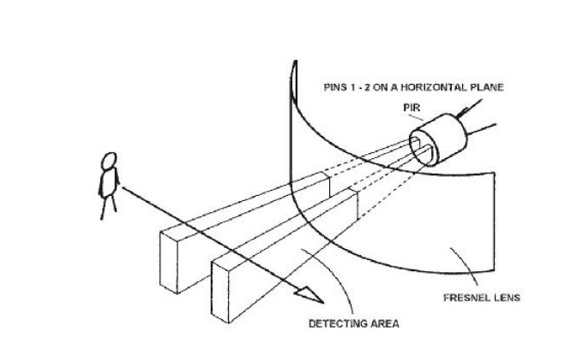

Human monitoring of surveillance video is a very labor-intensive task. Detecting multiple activities in real-time video is difficult in manual analysis. Thus the Intelligent video surveillance system is emerged. The analytics software processes video flow images to automatically detect objects (peoples, equipments, vehicles) and event of interest for security purposes. Observing or analyzing a particular site for safety and business purposes is known as video surveillance. Security and crime control concerns are the motivating factors for the deployment of video surveillance cameras. Video surveillance cameras are used in shopping centres, public places, banking institutions, companies and ATM machines.

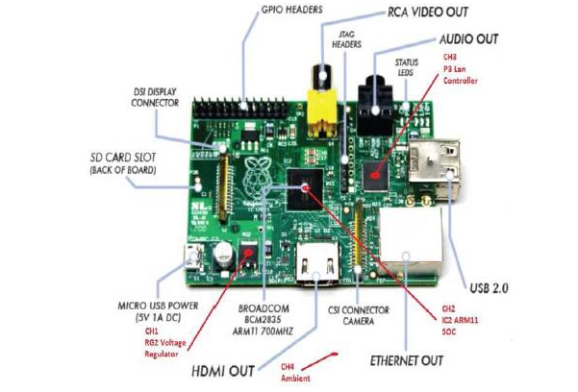

Nowadays, researches experience continuous growth in network surveillance. The reason being is the instability incidents that are happening all around the world. Therefore, there is a need of a smart surveillance system for intelligent monitoring that captures data in real time, transmits, processes and understands the information related to those monitored. The video data can be used as a forensic tool for after- crime inspection. Hence, these systems ensure high level of security at public places which is usually an IoT Based Smart Security Surveillance System As video cameras are available at good price in the market, hence video surveillance systems have become more popular. Video surveillance systems have wide range of applications like traffic monitoring and human activity understanding. In video surveillance system we demonstrate a system which analyses activity in the monitored space in real time, and makes the events available for generating real time alerts and content based searching in real time. Advantages of video surveillance:

Availability- There was a time when the• surveillance techniques were utilized only in shopping centers and malls. Now-a-days, you can notice closed-circuit televisions almost at any place you visit, from a small store to homes and holy places. As a result, they guarantee greater public security at a fraction of the cost. Real-time monitoring- Traditionally big

• organizations have always had the benefits of video surveillance manned by security professionals. In the past times, the events captured on video were used to expose important information and work as proof after the event happened. But, modern technologies let users to check and reply to alarms immediately.

1. **Proposed system**

The main aim of this project is the utilization of Raspberry Pi to depict a security alert framework utilizing low processing power chips utilizing Internet of things which screens and get alerts when movement is identified and sends photographs and recordings to a cloud server. Moreover, Internet of things (IoT) based application can be utilized remotely to see the movement and get warnings when movement is identified. The photographs and recordings are sent straight forward to a cloud server, sent as Gmail Notifications with snapshots and SMS alerts and when the cloud is not accessible then the information is put away locally on the Raspberry Pi and sent when the association resumes. Accordingly, points of interest such as these make this applications perfect for smart security surveillance monitoring where ever the security is a big concern and required security alert system with instant notifications such as in Industries, Banks, IT Offices and in Homes, this system can be best utilized. The whole report is centered on the field of embedded system, Internet of Things and the use of Linux based OS to run applications on them. Existing system In the existing method the Raspberry Pi is connected to web camera to detect and capture the snapshots, videos of the motion when detected and the RJ45 LAN cable to connect to the Internet for sending and receiving data.

The data can be uploaded to external server such as FTP or SFTP or Cloud Servers. Raspberry Pi executes the processing of all the data and after the data is analyzed then uploading images and videos to the ftp server and instant GMAIL notifications with attached snapshots to user. Fig.1. Internet based motion detection. An Internet of Things Approach for Motion Detection and Controlling Home Appliances without Cloud Server: This paper presents about monitoring and controlling of home appliances from outside and also monitoring the motion detection in home for unauthorized person detection, office, industry for monitoring the machineries etc. Here we are going to avoid the use of external cloud server for which we have to pay some amount monthly to get space there. Now a day's cost is a important factor. So this project will be useful to mainly reduce the cost for monitoring the motion from outside. So to implement this method we are going to use ARM11 processor and Raspberry pi which is going to act as a server in home side and ARM11 is going to capture the pictures and finally these pictures converted into video then this video will be sent to web Page that we created or sent to one URL, or one IP address. So that we can see what is happening in our house or office by just entering the URL or IP address.

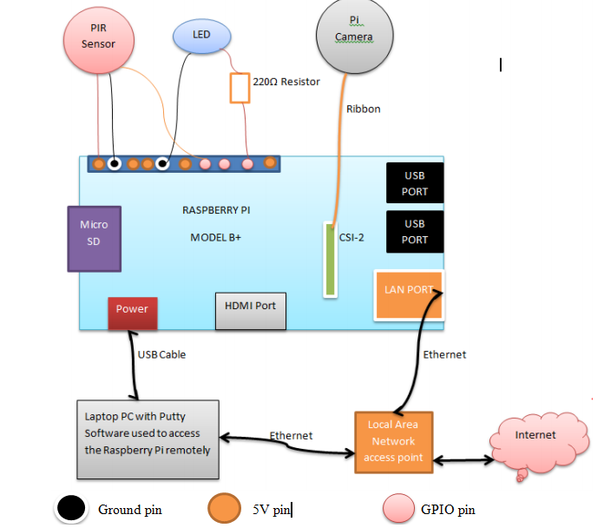

In this System, we have a tendency to develop a brand new approach for motion detection. The Block diagram of the proposed system consists of Raspberry Pi board (Model B+) ,Wi-Fi Module, GSM Module, USB Camera and PIR sensor. Raspberry Pi model B+ is connected to the USB camera (2 Megapixels) with the help of USB port .The operating system installed in Raspberry pi is Raspbian operating system. The diagram of the planning is as shown in Fig.2. It consists of Raspberry pi processor, USB camera, GSM module etc. The temporary description of every unit is explained as follows. ISSN: 2278 – 909X International Journal of Advanced Research in Electronics and Communication Engineering (IJARECE) Volume 7, Issue 5, May 2018 483 All Rights Reserved © 2018 IJARECE Fig.2. Block diagram of proposed system. The project aims to simplify motion detection and the interface to be user friendly, which would send prompt notifications when motion is detected using Raspberry Pi which depict a security alert framework utilizing low preparing power chips utilizing Internet of things which screens and get alerts when movement is recognized and sends photographs and recordings to a cloud server. The photographs and recordings are sent to cloud managed service Drobox, Gmail Notifications with snapshots and SMS alerts to the user. When the cloud is not accessible then the information is stored locally on the Raspberry Pi and sent when the association resumes. The primary functions of the project are Detect Movement: Python script would analyze the video of the USB WEB Camera, if there is a difference from the last frame to current frame it would be flagged and video recording and snapshots generation will begin. On Movement Detected: When movement is detected, then python script will execute on the Raspberry Pi to send an email to the registered Email 9with attached snapshots and SMS notifications to registered mobile number. On Snapshot Save: When a snapshot is saved, by default it is saved locally on the SD card of the Raspberry Pi. Shell script will upload the snapshots to cloud managed service Dropbox, which supports command line Linux based commands. The snapshots are saved instantly if there is a breach in the surroundings/house and the person tries to remove the setup still the snapshots already been stored to external cloud service Dropbox as configured. A. Raspberry Pi The Raspberry Pi could be a credit-card sized pc that plugs into your TV and a keyboard. It’s a capable very little pc which might be utilized in physical science comes, and for several of the items that your desktop computer will, like spreadsheets, word-processing and games. It additionally plays high-definition video.

The Raspberry Pi features a Broadcom BCM2836 system on a chip (SoC), which has an ARM1176JZF-S 700 MHz processor, VideoCore IV GPU, and was originally shipped with 256 megabytes of RAM, later upgraded (Model B & Model B+) to 512 MB. It doesn't embody an intrinsic hard disc or solid-state drive, however it uses SD card for booting and protracted storage, with the Model B+ employing a MicroSD. B. GSM Modem Communication among vehicle, Owner, police and emergency is established consequently as per demand through GSM (Global Service for Mobile communication). GSM is electronic equipment that accepts a SIM card, and operates over a subscription to a mobile operator, a bit like a mobile. GSM modems are often an obsessive electronic equipment device with a serial, USB or Bluetooth association or it should be a mobile that has GSM electronic equipment capabilities. GSM electronic equipment might even be a regular GSM mobile the acceptable cable and software system driver to attach to a port or USB port on our pc. C. Wi-Fi Dongle USB Wi-Fi dongle plugs into Raspberry Pi's universal serial bus (USB) ports, allowing you to connect to a wireless network in the industries, office, home, or a public place. You can use this connection to access shared files, devices, and documents, or to connect to the Internet. A USB device is often less expensive than a replacement network card. Adapters tend to be bulkier than dongles, but more powerful. However, dongles fit in the pocket, so are more portable. Enabling a Wi-Fi network by adding a USB Wi-Fi dongle has several benefits. In the home, it allows Raspberry Pi connect to the Internet without running cables throughout the building or house and can share same internet with computers or mobile phones or laptops. D. Flowchart and Algorithm Once the flowchart is drawn, it becomes easy to write the program in any high level language. Often we see how flowcharts are helpful in explaining the program to others.

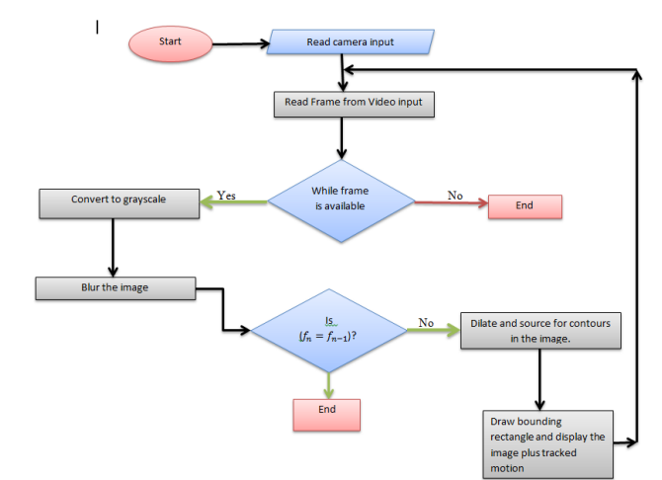

i. Start the camera and set to capture video stream ii. Grab a frame from the video stream. If frame is grabbed, continue with the process. Else stop. Initialize the frame as the current frame iii. Convert the captured frame to grayscale. Then do Gaussian blurring to remove noise in the gray image iv. Capture another frame and repeat step two above. v. Check for pixel threshold if enough to call motion detected vi. Draw a rectangle around the region where motion was detected

1. **Conclusion**

Hence IoT based smart security surveillance system using Raspberry pi have been successfully designed and implemented which is capable of recording the videos and capturing the images and the same has been uploading to cloud service Dropbox if it is not available then stores locally on Raspberry Pi storage. At the same time SMS notifications and Gmail notifications with captured snapshots will send to user. Live video streaming also provided to monitor continuously. It is advantageous as it offers reliability and privacy on both sides. It is authenticated and encrypted on the receiver side; hence it offers only the person concerned to view the details. Necessary action can be taken in short span of time in the case of emergency conditions such as industries, offices, military areas, smart homes, elderly person falling sick etc.

1. **REFERENCES**

[1] Z. Sundas, “Motion Detecting Camera Security System with Email Notifications and Live Streaming Using Raspberry Pi.” .

[2] M. Peter and H. David, “Learn Raspberry Pi with Linux,” Apress, 2012.

[3] P. S. Dhake and B. Sumedha S., “Embedded Surveillance System Using PIR Sensor.,” vol.No. 02, no. 3, 2014.

[4] J. D., “Real Time Embedded Network Video Capture And SMS Alerting system,” Jun.2014.

[5] S. Sneha, “IP Camera Video Surveillance using Raspberry Pi.,” Feb. 2015.

[6] F. C. Mahima and A. Prof. Gharge, “Design and Develop Real Time Video Surveillance System Based on Embedded Web Server Raspberry PI B+ Board. International Journal of

Advance Engineering and Research Development (Ijaerd), NCRRET.,” pp. 1–4, 2015.

[7] J. G. J, “Design and Implementation of Advanced ARM Based Surveillance System Using Wireless Communication.,” 2014.

[8] P. Sanjana, J. S. Clement, and S. R., “Smart Surveillance Monitoring System Using Raspberry PI and PIR Sensor.,” 2014.

[9] U. Kumar, R. Manda, S. Sai, and A. Pammi, “Implementation Of Low Cost Wireless Image Acquisition And Transfer To Web Client Using Raspberry Pi For Remote Monitoring.

International Journal of Computer Networking, Wireless and Mobile Communications (IJCNWMC).,” vol. No. 4, no. 3, pp. 17–20, 2014.

[10] “The History of Security _ PerspecSys.com.htm.” .

[11] A.-D. Osama, “Cisco IP Video Surveillance Introduction,” Cisco Expo, 2009.

[12] “What is a security system and how does it work _ SafeWise.htm.” .

[13] T.K. Hareendran, “GSM Home Security Alarm System With Arduino,” Library Security System, 2014. .

[14] R. Verman, “Distance Education In Technological Age,” Anmol Publ. Pvt Ltd, p. 166,2005.

[15] “Television Rides Wires,” Pop. Sci., no. February, p. 179, 1949. [16] “Introduction to Closed Circuit Television,” Jan-2013. .

[17] B. Messauod, Access Control Systems: Secuiry, Management and Trust Models., 1st ed.Austin, TX, USA: Springer, 2006.

[18] “IP Surveillance,” IT Encyclopedia.

[19] “ijcsit2014050648.pdf.” .

[20] B. E. Reddy, M. Veeresha, and N. Rao, “Image Processing: A Survey.”

[21] A. Ambrosetti and P. H. Rabinowitz, “Dual variational methods in critical point theory and

applications,” J. Funct. Anal., vol. 14, no. 4, pp. 349–381, 1973.